Bahria University,

Karachi Campus



LAB EXPERIMENT NO.

**02**

LIST OF TASKS

|  |  |
| --- | --- |
| TASK NO | OBJECTIVE |
| 1 | Create class diagram of University Registration and using that diagram apply concept of forward engineering in Rational Rose. |
| 2 | Apply concept of reverse engineering to create the class diagram using java code in Rational Rose. |
|  |  |
|  |  |
|  |  |

Submitted On:

27/02/2020

(Date: DD/MM/YY)

**Task # 01:** Create class diagram of University Registration and using that diagram apply concept of forward engineering in Rational Rose.

**Input:**

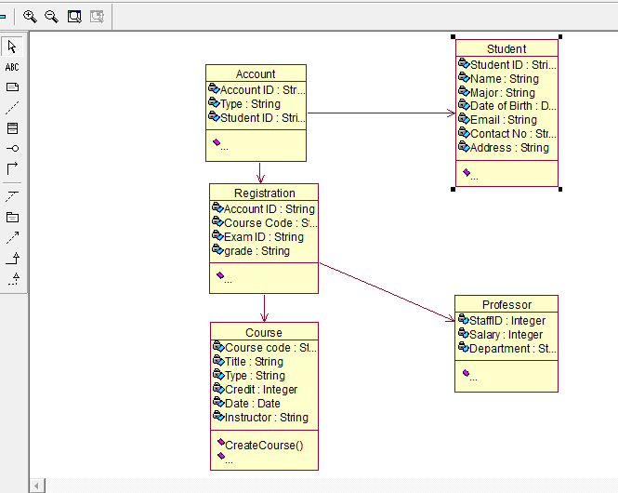

**Result:**

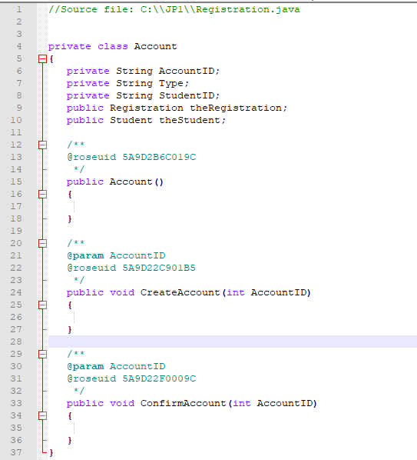

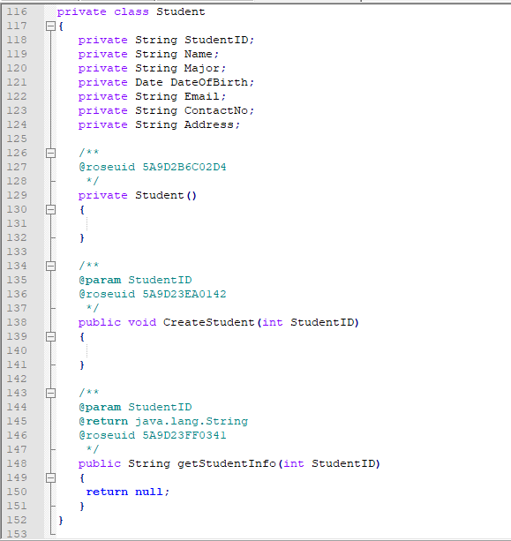

**Task # 02:** Apply concept of reverse engineering to create the class diagram using java code in Rational Rose.

**Input:**

private class Account

{

private String StudentID;

public Account()

{

}

public void CreateAccount(int AccountID)

{

}

}

private class Course

{

private String CourseCode;

private Date Date;

private String Instructor;

private Course()

{

}

public void CreateCourse(int CourseCode)

{

}

public void DropCourse(int CourseCode)

{

}

}

private class Professor

{

private Integer StaffID;

private String Department;

private Professor()

{

}

public void CreateProfessor()

{

}

public String getProfessorInfo()

{

return null;

}

}

private class Student

{

private String StudentID;

private String Name;

private Date DateOfBirth;

private String Email;

private String ContactNo;

private Student()

{

}

public void CreateStudent(int StudentID)

{

}

public String getStudentInfo(int StudentID)

{

return null;

}

**}**

**Result:**

